Registration Timeline 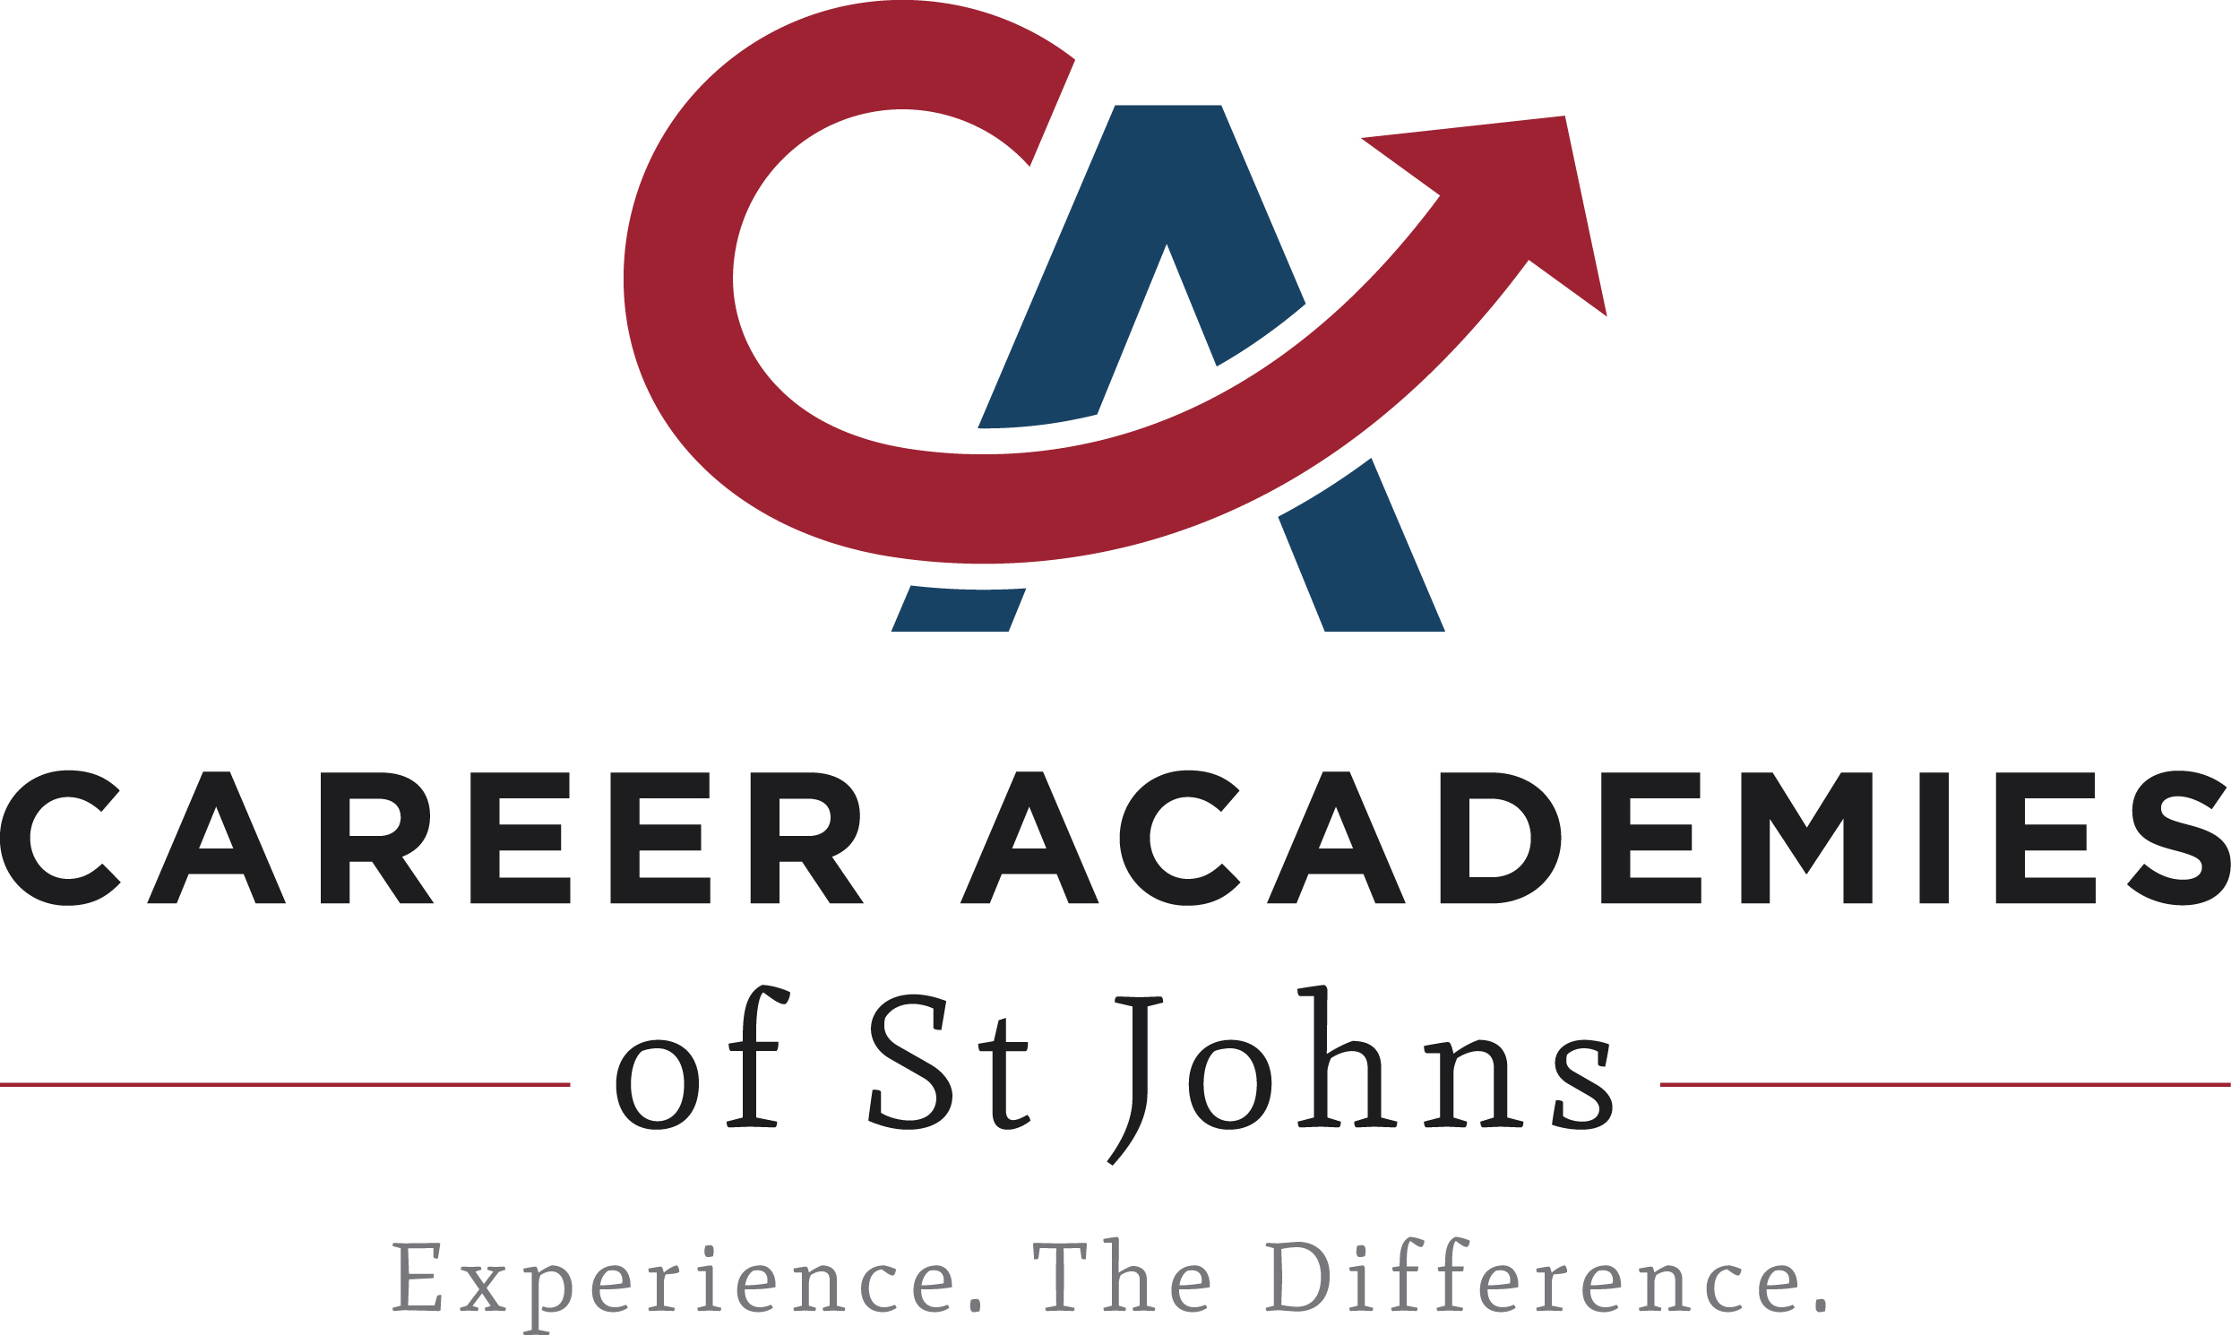
Application submission deadline for students currently enrolled in a St. Johns County public school: February 19, 2019, by 5:00 p.m.

Timeline
Dec. & January | Middle School Blitz held at each Middle School
January 24 | High School Showcase at World Golf Village Convention Center – 3:30 – 7:00 p.m.
January 24 | Online Application OPENS for newly applying 5th, 8th and 9th grade students.
Jan. 29- Feb. 5 | Academy Nights (see schedule below)
February 15 | St. Johns County Center for the Arts AUDITIONS at St. Augustine High School.  Murray Middle School Arts auditions will be held at Murray Middle School. Please bring your printed audition form.
February 19 | Registration Deadline – Online registration will be closed at 5:00 p.m. Paper applications must be received prior to the end of the school day.
May 1 | Last day for late applications
June 1 | Last day to apply for review
July 1 | All out of zone placement decisions will be finalized

High School Showcase

All parents and students are invited to attend the annual High School Showcase on Thursday, January 24, 2019 at the World Golf Village Convention Center from 3:30 – 7:00 p.m. Learn about the high school Programs of Choice and meet representatives from each high school.

Academy Nights
Each high school will host an informational 2019 Academy Night. All parents of students interested in attending one of the academies should make plans to attend these events. Each Academy Night will begin at 6:00 p.m., except for St. Johns Technical High School which will begin at 5:30 p.m.
January 29 | St. Johns Technical | 5:30 – 6:30pm
January 29 | St. Augustine  ALL St. Johns County Center for the Arts and Murray Middle School requests must apply by February 19, 2019. (Auditions at St. Augustine High School and Murray Middle School will occur on February 15, 2019) | 6:00 – 7:30pm
January 30 | Allen D. Nease | 6:00 – 7:30pm
January 31 | Bartram Trail | 6:00 – 7:30pm
February 4 | Creekside | 6:00 – 7:30pm
February 5 | Pedro Menendez | 6:00 – 7:30pm
February 5 | Ponte Vedra | 6:00 – 7:30pm

Any SJCSD resident who is moving a student from home school, virtual school or private school may apply for an academy by pre-registering at their current zoned school and complete a Program of Choice paper application at that time, for inclusion in the application process. All paper applications need to be received at the school prior to the close of the school day, by February 19.

If you should have any questions, please feel free to contact Theresa Dodd at 904-547-4870 or Theresa.Dodd@stjohns.k12.fl.us.

