Switzerland Point 2017-2018

8th Grade PG/PG-13 Permission Slip

Please return, with your DC permission form, to Ms. Robbins

At various times throughout the DC trip students may watch a G/PG/PG-13 rated movie on the bus. The movies will primarily be played for entertainment purposes; however, we do have two brief films that will be shown for educational purposes.

Please sign this form to give your child permission to watch these movies.

Student’s Name ____________________________________________

Guardian’s Name _____________________________ Relationship ____________________________

Guardian’s Signature ___________________________________ Date __________________________

-------------------------------------------------------------- cut here --------------------------------------------------------------

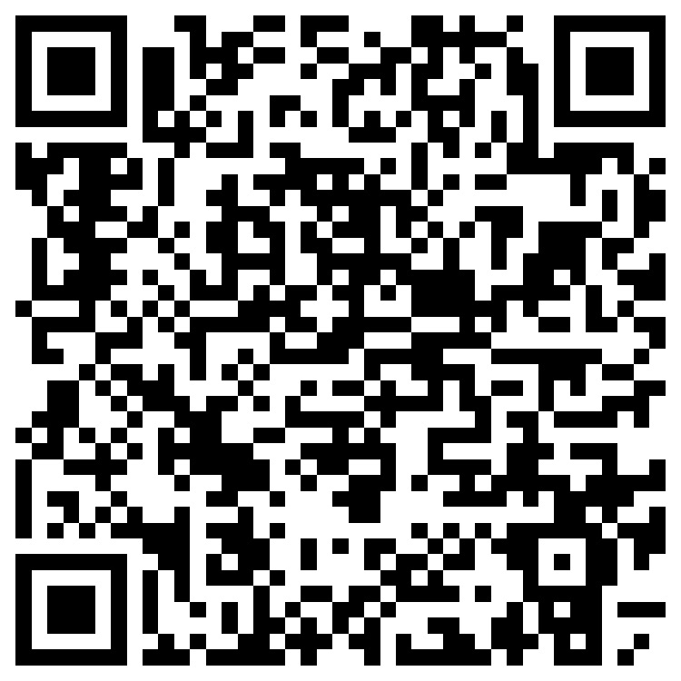
DC Payment Dates
Total cost = $900/student $995/adult
Payment plan for Students/Parents
Complete Google Form ASAP to hold seat using QR code or the link posted on the SPMS website.
$450/$500 Payment 1 - Sep 15th
$450/$495 Payment 2 - Nov 1st

Last day to request a full refund – October 31st
Partial scholarships and flexible payment plans are available, but parents must contact Deborah Robbins by Friday, September 1st.

